* **Smoke Detector Alarm**

**Circuit:**

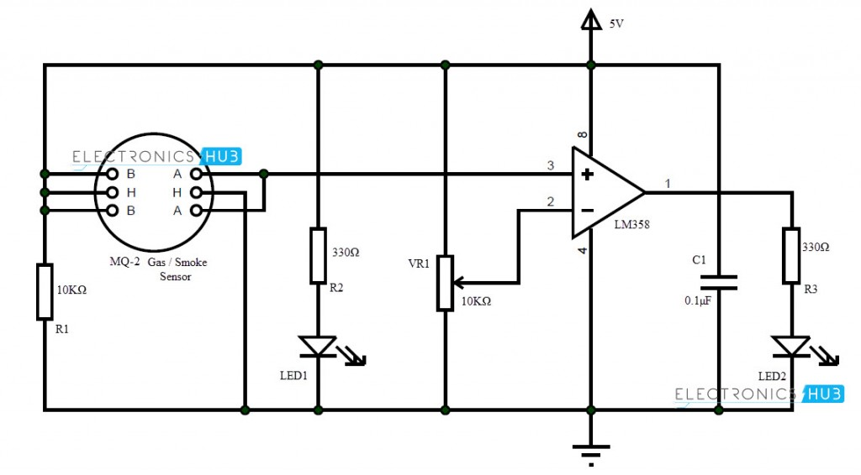

### Working:

We used a Smoke Sensor MQ-2 as the main sensory device. The working of the circuit is simple and is explained below.

LM358 acts as a comparator in this circuit. The inverting terminal of LM358 is connected to POT so that the sensitivity of the circuit can be adjusted.

The output of LM358 is given to an LED as an indicator although a buzzer can be used as an alarm. The non-inverting terminal of LM358 is connected with output of smoke sensor.

Initially, when the air is clean, the conductivity between the electrodes is less, as the resistance is in the order of 50KΩ. The inverting terminal input of comparator is higher than the non-inverting terminal input. The indicator LED is OFF.In the event of fire, when the sensor is filled with smoke, the resistance of the sensor falls to 5KΩ and the conductivity between the electrodes increases.This provides a higher input at the non-inverting terminal of comparator than the inverting terminal and the output of comparator is high. The alarming LED is turned ON as an indication of presence of smoke.